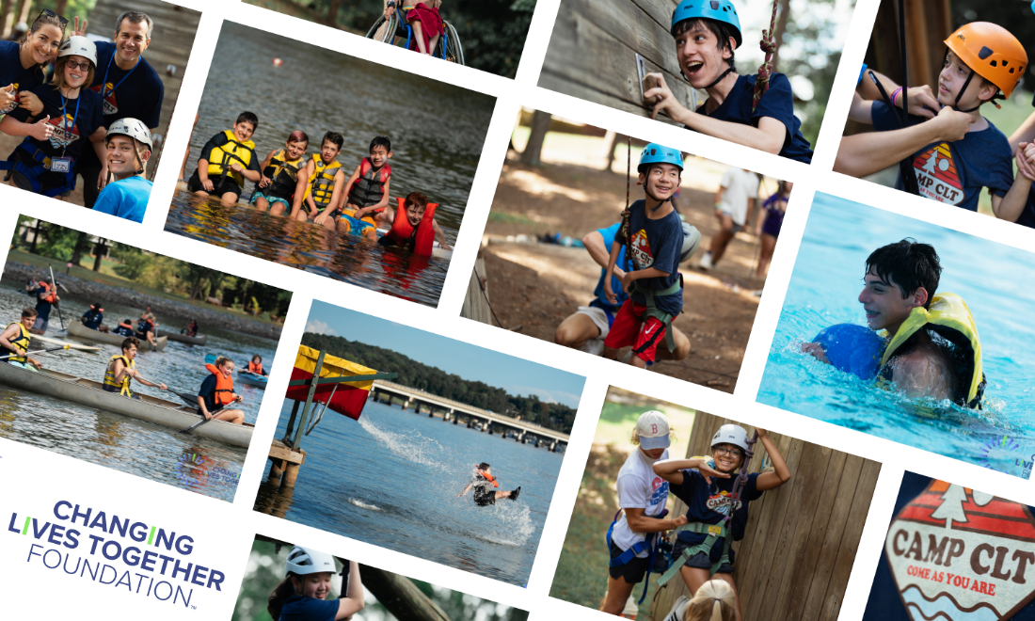
Camp CLT
September 13-15, 2024 at Camp Thunderbird on Lake Wylie
1 Thunderbird Lane, Clover SC, 29710
Check in: 4pm on Friday, Sept 13. Pick up: 3-4pm on Sunday, Sept 15.

Overview
The Changing Lives Together Foundation will be hosting Camp CLT - a free outdoor camp at Camp Thunderbird specifically designed for and exclusively for kids with physical disabilities who are in grades 4th thru 12th for the 2024-2025 school year. This is a two-night sleep away camp. Camp CLT will be capped at 40 kids only.

Our organization has worked with the staff of Camp Thunderbird to design a camp where all kids of all ability levels will be able to participate in a safe, inclusive and fun camp. Camp CLT will feature activities coordinated and administered by Camp Thunderbird trained staffed like archery, climbing wall, canoeing, kayaking, pool time, giant slide into the lake, plus plenty of other fun activities for the kids throughout the weekend. We have made sure all of these activities are as accessible as possible and when there’s a little extra help needed, we will have volunteers at the ready to be sure the kids are safe, feel comfortable and can be successful!

Check out last year’s Camp Highlight Video – click here Camp CLT
Medical Staff and Volunteers on site at Camp CLT based on 40 campers

For the entire camp, including all overnight periods and including all evening and early morning medications/bathroom/showering/dressing duties, we will have at least 5 nurses/CNAs on staff with at least 3 of them being RNs.

In addition to the above medical staff, during all awake hours, there will be a 1 to 1 ratio of campers to adult volunteers. Each volunteer will be assigned to 1 camper to assist with transportation, activities, meals or anything else that they may need that does not require medical staff.

Overnight sleeping
Male and female campers will be sleeping in separate cabins. There will be approximately 6-8 kids sleeping in each cabin and we will have 1-2 adults sleeping in each of the cabins. Any adult sleeping in the cabin will be vetted through the CLT Foundation and will have a background check run on them prior to the camp.

Important Notes
- In order for the CLT Foundation to ensure a successful experience for the kids, this camp is intended for kids whose primary diagnosis is a physical disability.
- All pages and sections of this application must be completed to be considered.
- If you have two kids who would like to attend, complete two separate applications.
- This is an application process; acceptance is not guaranteed. Decisions will be communicated via email at least one month prior to the arrival date.
- Unfortunately, the CLT Foundation may not be able to accommodate all who apply. While we would love to serve all applicants, there is a limited number of spots. If your camper is put on the waitlist, you will be notified if a camp opportunity becomes available.
- If you have any questions or when your application is completed, email it to Office@cltfoundation.org.
- Registration CLOSES and applications will no longer be accepted after August 15.

High Level Weekend Itinerary

Friday
4pm – Check-in and Orientations
5 – 6pm – Introduction and Games
630 – 730 – Dinner
730 – 10pm – Dance Party, outside games, small activities, smores, guest speaker(s)

Saturday
8 – 9am – Breakfast
930 – 1230 – Land Activities (Climbing Wall, Field Day games, archery/BB guns)
1230 – 1pm lunch
1 – 215 – Rest/Change
230 – 545 – Kayaking, canoeing, pool, slide. Based on our projected camp size, there will be at least 4 lifeguards provided by the YMCA at all times.
630 – 730 – Cookout
8 – 10pm – Movie, Games and Popcorn

Sunday
830 – 930 – Breakfast
10 – 1 – Tree climbing, giant slip n slide, outdoor games
1 – 2pm – Lunch
2 – 4pm Pack Up and Wrap Up
3 – 4pm – Pick up

** More information and a check list of what to bring to the camp will be emailed to all campers if/when their application is approved and closer to the actual Camp date. **

Name of Applicant_________________________________________________

Primary Diagnosis __________________________________________________

Other Diagnosis (list all) _________________________________________________

Age of applicant as of Sept 13, 2024 ____________________________________

Grade in school as of Sept 13, 2024 _____________________________________

Full Name of parent completing application_______________________________

How did you hear about this camp? Through what organization or referring group/friend or on what social media platform? ______________________________________________________________________________

Basic Medical Information
Height ________ Weight ___________

Emergency Contact Information

Primary Emergency Contact
Name _____________________________ Relationship__________________________
Cell Phone number____________________ Alternate phone number ___________________

Secondary Emergency Contact
Name _____________________________ Relationship__________________________
Cell Phone number____________________ Alternate phone number ___________________

Preferred Hospital to be taken to in case of emergency:

Name _______________________________

Phone Number _______________________________

Health Insurance Information
Include an image/copy of the front and back of the insurance card in which camper is covered.

Insurance company / name of carrier______________________________________________

Insurance company phone number_________________________________________________

Group number___________________ Policy number_________________________

Primary Insurance subscriber's full name__________________________________

Primary Insurance subscriber's date of birth_____________________________

SECONDARY Health Insurance Information (IF APPLICABLE)
Include an image/copy of the front and back of the insurance card in which camper is covered.

Insurance company / name of carrier______________________________________________

Insurance company phone number_________________________________________________

Group number___________________ Policy number_________________________

Primary Insurance subscriber's full name__________________________________

Primary Insurance subscriber's date of birth_____________________________

Medical Information

Does this individual applicant have any medical conditions which might compromise his/her immune system from being able to fight off infections?
Examples: Any cancer requiring chemotherapy, or which has been in remission for less than 3 years | Any primary immunodeficiency disease | Any condition requiring medications, such as steroids or biologic modifiers which could lower your immune system (e.g., lupus, juvenile arthritis, chronic kidney disease) | Active heart or lung disease requiring treatment (e.g. congestive heart failure, asthma) | Any condition which could be actively triggered or worsened by an infection (e.g. diabetes)

Yes____ No_____ If you answered yes, please elaborate on the applicant's diagnosis:

Please list any medical conditions and considerations we should be aware of:

Please list any allergies to medications or environment (bee stings, severe animal allergies):

Please list any supportive devices or braces (wheelchair, Oxygen, BiPAP, etc):

Please list any physical restrictions or limitation to activity:

My child is up to date on vaccinations for his/her age:
Select: Yes____ No_____ If no, please explain.

Medications and Allergies

Medications
Please write NONE here ________________ if your child has no medications, even emergency medicines like Epi-pen, they will or possibly will take while at camp and will therefore be bringing with them.

In the list below, please include all emergency medications (Epi-pen, Dia-stat, etc.)

"Medication" is any substance a person takes to maintain and/or improve their health. This includes vitamins & natural remedies. Please review camp instructions about required packaging/containers. Many states require original pharmacy containers with labels which show the patient's name and how the medication should be given. Provide enough of each medication to last the entire time while at camp.

Medication #1
Name and strength of medication

Dosage

Reason for taking

How given

Include detailed notes or special instructions.

When is the medication delivered?
- Breakfast (8:30-9:00)
- mid-morning
- Lunch (12:30-1:00)
- Dinner (6:30-7:30)
- Bedtime (10:00-10:30)
- Other (please explain in notes)
- As needed

*** If needed, copy this page for each additional medication needed ***

Allergies

Allergy #1
Please write NONE here ________________ if your child has no food, environmental or other allergies that you are aware of.

Type of allergen
Environmental______ Food______ Medicine______Other _______

Describe specific allergy and reaction seen ___________________________________________
______________________________________________________________________________
______________________________________________________________________________

Allergy #2
Type of allergen
Environmental______ Food______ Medicine______Other _______

Describe specific allergy and reaction seen ___________________________________________
______________________________________________________________________________
______________________________________________________________________________

Forbidden OTC Medications
The following non-prescription medications may be stocked and are used on an as needed basis to manage illness and injury. Add an “X” below next to the ones that should NOT be given.
- Tylenol (Acetaminophen) ____
- Advil (Ibuprofen)____
- Benadryl____
- Antibiotic Cream____
- Cough Drops____
- Tums____
- Sudafed____
- Robitussin____
- Pepto Bismol____
- Imodium____
- Other_______________ ____

Important - Briefly, describe your child’s personality, social skills or anything else important that we should know. Example: are there things that will take us extra time in the morning/day that we should be prepared for? Is your son/daughter fully independent besides doing ____ in the morning or evening? What activities/ADLs are they NOT independent with?
__________________________________________________________________________________________________________________________________________________________________________________________________________________________________________
______________________________________________________________________________
______________________________________________________________________________
______________________________________________________________________________

Family Consent Form

Activity Consent
I recognize the possible physical risk involved in providing residential facilities and recreational activities for the family members specified on our application (hereafter referred to as Attendees). Attendees are authorized to participate in any and all officially administered, sponsored or sanctioned activities at Camp CLT as the parent(s) chooses. Further, I hereby release, discharge and otherwise indemnify Camp CLT, Camp Thunderbird/YMCA, its affiliated organizations and sponsors, its officers, directors, employees, volunteers and agents (the "Camp Parties") against any claim by or on behalf of Attendees as a result of our participation in any program or activity sponsored, coordinated, or supervised by Camp CLT. I also agree to release, discharge and agree to hold harmless and indemnify the Camp Parties with respect to any medical expenses resulting from personal injuries sustained by Attendees while engaged in such activities or otherwise at the Camp facilities. I also understand that this release includes traveling to or from the programs or activities.
Assumption of Liability for Damage to Camp Property
I understand that I, as the parent and/or guardian, will be responsible for paying for any damage or destruction of camp property arising as a direct or indirect result of the actions of my camper. Camp CLT is not responsible for any lost, stolen or damaged personal items.
Photo/Media Release
I also give CLT Foundation, Camp Thunderbird, camp sponsors, and Camp CLT authorized news media permission to photograph and to use pictures, video, or audio tapes of Attendees either alone or in groups for newsletters, advertising purposes, fundraising activities, bulletin boards, camp albums or in promoting public understanding and support for their causes. Camp CLT respects the privacy of its campers and their families and will use its best efforts to assure that unauthorized visitors are not photographing campers.
Medical Treatment, Waiver and Release
I hereby grant permission to the medical staff at Camp CLT and Camp Thunderbird, or such designees as the medical staff may appoint, to provide routine and emergency medical care required for Attendees, including, without limitation, medications, immunizations, x-rays, dental care, hospitalization, general anesthesia, or other medical treatment as may be appropriate while Attendees are in the care of Camp CLT. I understand that the care of Attendees may require action by the medical staff before I can be contacted. I also give my consent for any transportation deemed necessary, in the sole discretion of the staff at Camp CLT, in connection with the treatment of Attendees. I also assume full financial responsibility for any and all medical and other expenses incurred on behalf of Attendees while at Camp CLT in connection with medical or other treatment, and acknowledge, agree and understand that Camp CLT shall not be liable for any such expenses. I understand that all information pertaining to Attendees will be treated as confidential by Camp CLT, but that said information may be shared with or released to appropriate personnel and/or third parties by Camp CLT for the purpose of treating and/or supervising Attendees (including, but not limited to referral centers, medical staff, psychological staff and/or insurance companies). Finally, I agree to release Camp CLT, its sponsors, volunteers, employees, officers, directors and agents of any liability arising from the administration or rendering of medical care.
WE ARE AN ALCOHOL, TOBACCO AND DRUG FREE FACILITY
We do not allow alcohol, tobacco (including smokeless tobacco), or illegal drugs on the premises at any time. This includes in your vehicle.
WE STRIVE TO BE A NUT FREE FACILITY!
Please do not bring any foods or products containing any nuts. Please also check labels to be certain that you are not bringing anything processed in a plant that also processes nut products.
WE ARE A WEAPONS FREE FACILITY
We do not allow weapons of any kind (including firearms, knives, pocket knives, etc.) on the premises at any time. This includes in your vehicle.
IF THESE POLICIES ARE VIOLATED, ANY ATTENDEE MAY BE ASKED TO LEAVE
I understand that Camp CLT has a No Alcohol, Tobacco, Illegal Drug, Weapon and Nut Policy. My signature below indicates that all attendees will comply with that policy for the duration of their time at Camp CLT.
I FULLY UNDERSTAND AND AGREE TO THE TERMS STATED ABOVE AND AGREE THAT ALL INFORMATION IS COMPLETE AND ACCURATE TO THE BEST OF MY KNOWLEDGE ON BEHALF OF MYSELF AND ALL ATTENDEES.

Parent Signature: __________________________________________________

Parent Name: _____________________________________________________

Date Signed: ______________________________________________________

When application is completed, please email it to Office@CLTFoundation.org
Registration CLOSES and applications will no longer be accepted after August 15

